Ex.no:5b | DATA VISUALIZATION USING MATPLOTLIB –  SALES DATA

AIM

To visualize and analyze the Google Play Store dataset using Line Chart, Bar Chart, and Pie Chart with Matplotlib to understand category-wise application trends, application review comparisons, and application type distribution.

ALGORITHM

Step 1: Import Pandas and Matplotlib libraries.

Step 2: Load the Google Play Store dataset into a DataFrame.

Step 3: Reconstruct the application category from the encoded category attributes and group the applications according to category.

Step 4: Calculate the average rating for each category and plot the category-wise rating using a Line Chart to observe variations in application ratings.

Step 5: Group the dataset according to application category and calculate the total reviews for each category.

Step 6: Plot the category-wise reviews using a Bar Chart to compare application popularity across different categories.

Step 7: Group the applications according to their application type and calculate the number of Free and Paid applications.

Step 8: Plot the application type distribution using a Pie Chart.

Step 9: Add suitable titles, axis labels, legends, and display the visualizations.

CODE

import pandas as pd

import matplotlib.pyplot as plt

df = pd.read_csv(

"Google_Play_Store_Analysis.csv",

encoding="latin1",

low_memory=False

)

category_columns = [col for col in df.columns if col.startswith("Category_")]

if category_columns:

df["Category"] = (

df[category_columns]

.idxmax(axis=1)

.str.replace("Category_", "", regex=False)

)

for column in ["Rating", "Reviews", "Installs", "Price"]:

if column in df.columns:

df[column] = pd.to_numeric(

df[column].astype(str)

.str.replace("$", "", regex=False)

.str.replace(",", "", regex=False),

errors="coerce"

)

category_rating = df.groupby("Category")["Rating"].mean().sort_values()

plt.figure(figsize=(12, 5))

plt.plot(

category_rating.index,

category_rating.values,

marker="o"

)

plt.title("Average Rating by Category")

plt.xlabel("Category")

plt.ylabel("Average Rating")

plt.xticks(rotation=90)

plt.grid(True)

plt.tight_layout()

plt.show()

category_reviews = (

df.groupby("Category")["Reviews"]

.sum()

.sort_values(ascending=False)

)

plt.figure(figsize=(12, 6))

plt.bar(

category_reviews.index[:10],

category_reviews.values[:10]

)

plt.title("Top 10 Categories by Total Reviews")

plt.xlabel("Category")

plt.ylabel("Total Reviews")

plt.xticks(rotation=45, ha="right")

plt.tight_layout()

plt.show()

type_distribution = df["Type"].value_counts()

plt.figure(figsize=(8, 8))

plt.pie(

type_distribution.values,

labels=type_distribution.index,

autopct="%1.1f%%"

)

plt.title("Free and Paid Application Distribution")

plt.show()
OUTPUT
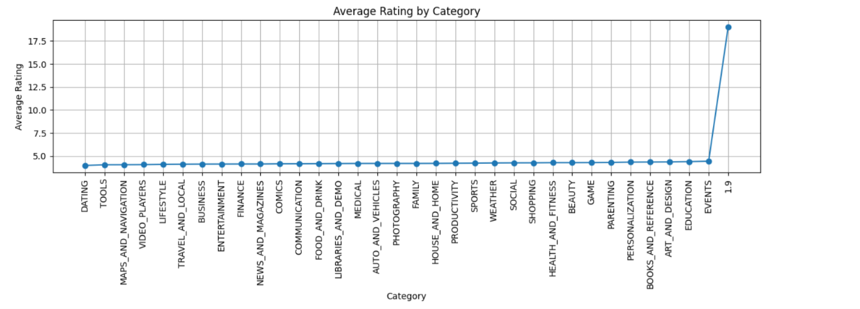
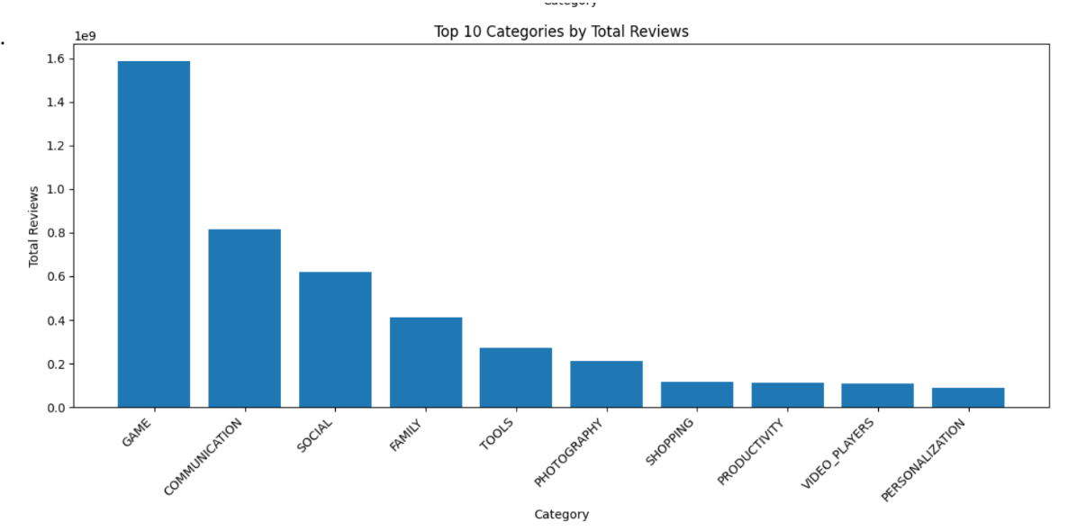
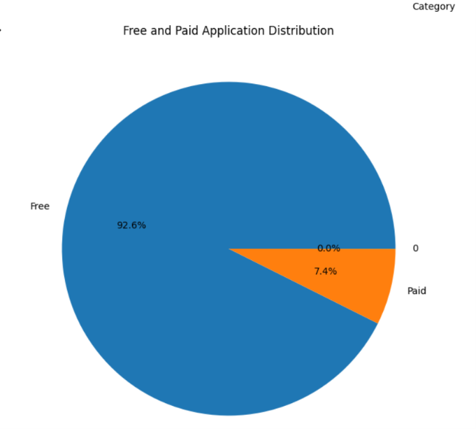

RESULT

